9.1 Create Multiple Slave Nodes

This section will guide you to:

* Create a master/slave architecture in Jenkins.

This guide has three subsections, namely:

9.1.1 Login to Jenkins

9.1.2 Create slave nodes

9.1.3 Push code to GitHub repositories

**Step 9.1.1:** Login to Jenkins

* Open your browser and navigate to **localhost:8081**
* Provide your username and password and click on **Login.**

**Step 9.1.2:** Create slave nodes

* Navigate to **Manage Jenkins.**
* Click on **Manage Node and Clouds.**
* Click on **New Node.**
* Provide name, number of executors, root directory path, label, usage, launch method, and WebDir path as shown below:

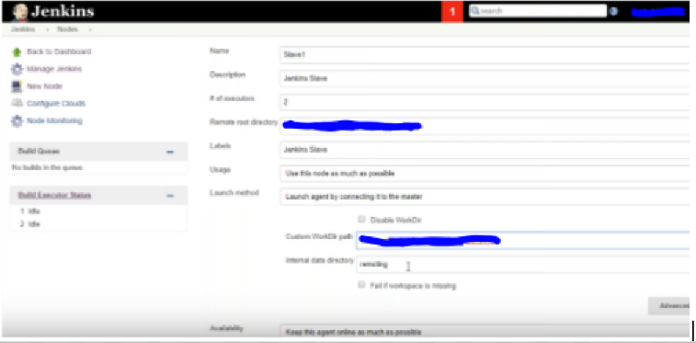

* Once the configuration is complete, you can see the slave machine on the dashboard.
* Download the **jar** file and copy the command provided to run the file.
* Run the command to start the slave node. Refer the screenshots given below:

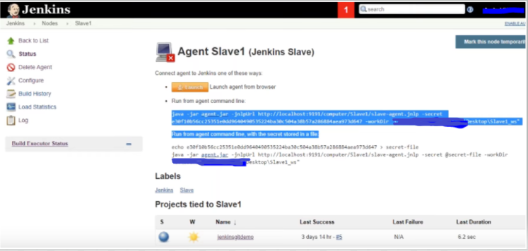

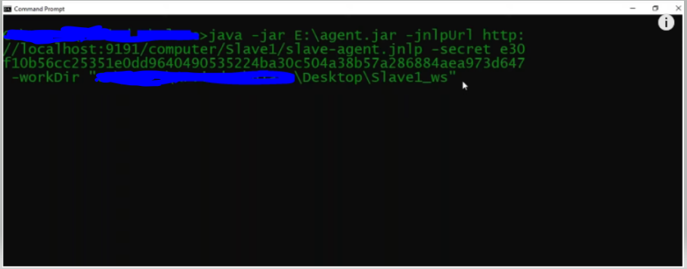

* Once the node is connected, click on the **Launch** button in Jenkins to start the slave machine.

**Step 9.1.3:** Push the code to your GitHub repositories.

* Open your command prompt and navigate to the folder where you have created your files.

**cd <folder path>**

* Initialize your repository using the following command:

**git init**

* Add all the files to your Git repository using the following command:

**git add .**

* Commit the changes using the following command:

**git commit . -m “Changes have been committed.”**

* Push the files to the folder you initially created using the following command:

**git push -u origin master**